EN3160 - Image Processing and Machine Vision

Assignment 1 - Intensity Transformations and Neighborhood Filtering
Name : Rajakaruna.R.W.M.D.S
Index : 220498D
GitHub Link :
Question 1 : Implementation of Intensity Transformation
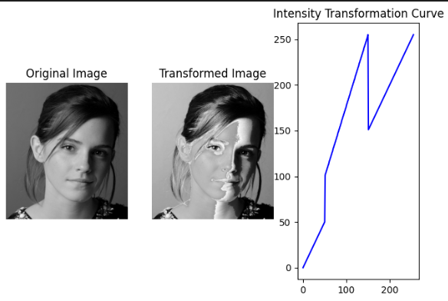
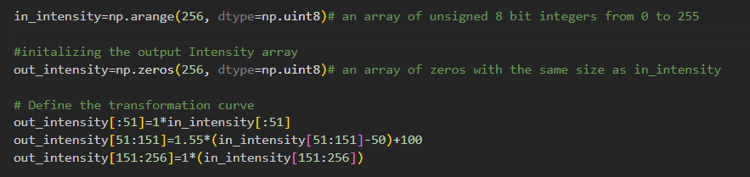
Implemented the expected Transformation Curve using ‘in_intensity’

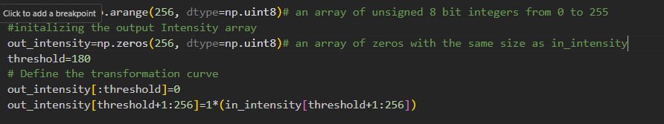
Question 2 : Implementation of Intensity Transformation

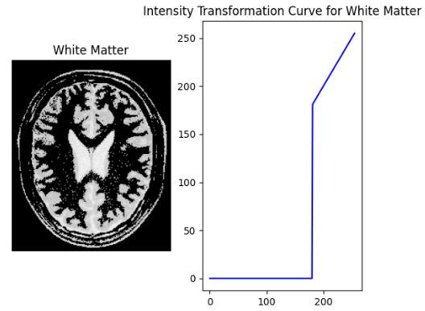

To make only the white matter visible, keep higher pixel intensities unchanged (linear curve with slope 1), and set everything below the thresholds to zero.

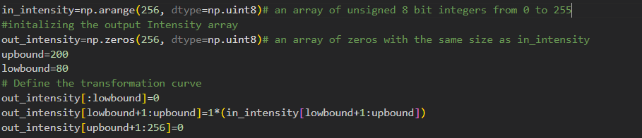
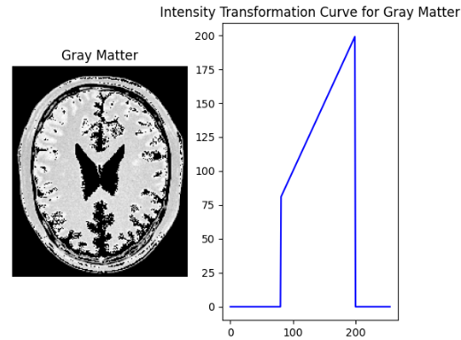

To make only the gray matter visible, keep the pixel intensities within the middle range unchanged (linear curve with slope 1), and set everything outside the upper and lower thresholds to zero.
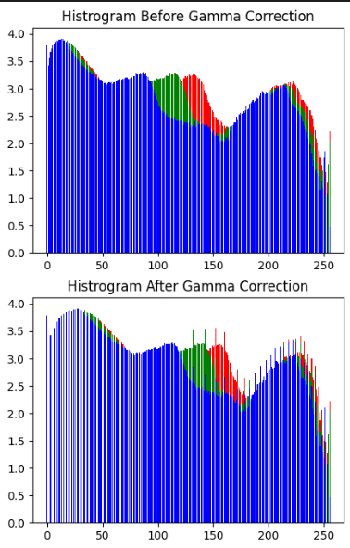
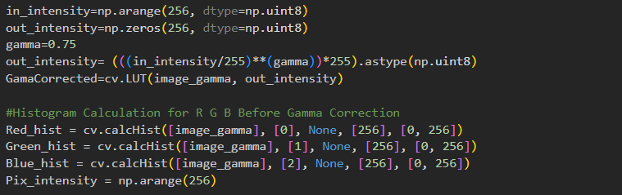
Question 3 : Gamma Correction

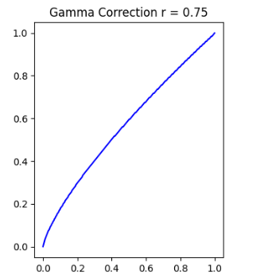
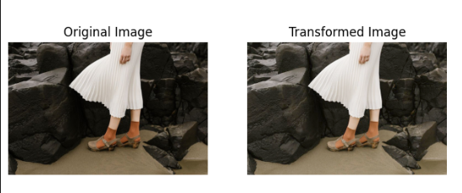

Here I used Logarithm of each color plane to visualize the color variation
and selected r =0.75 for this case

Question 4 : Intensity Transformation Using a function

